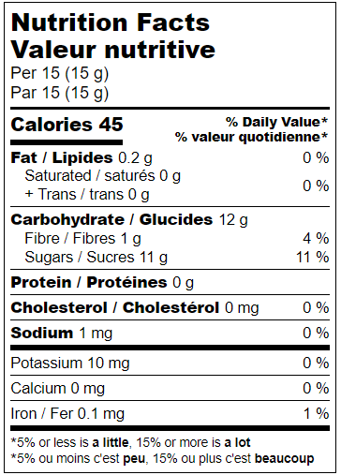 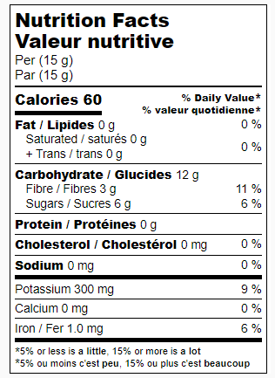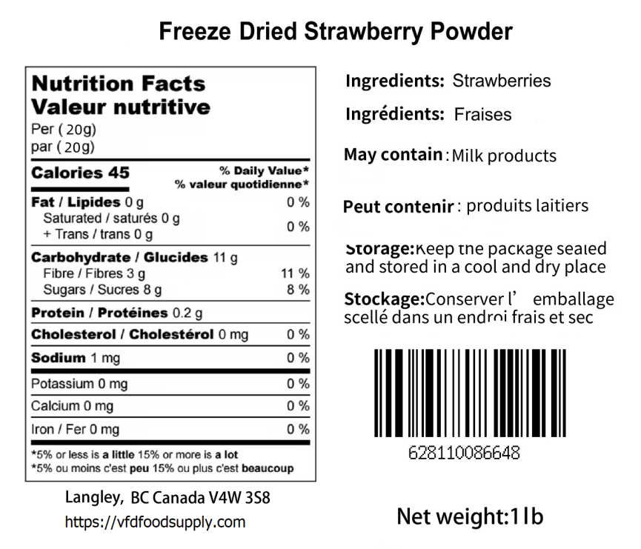

Canneberge, Sucre de canne

Cranberry, Cane sugar

**Freeze Dried Cranberry**

BB: Nov 13, 2025 LOT:D