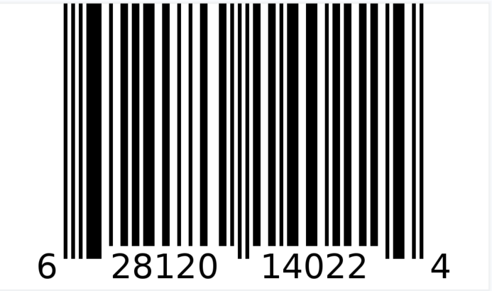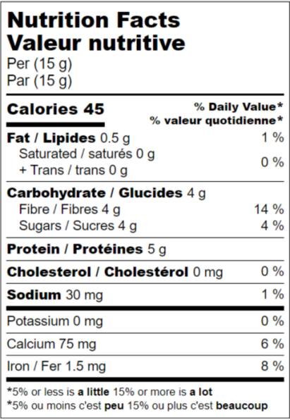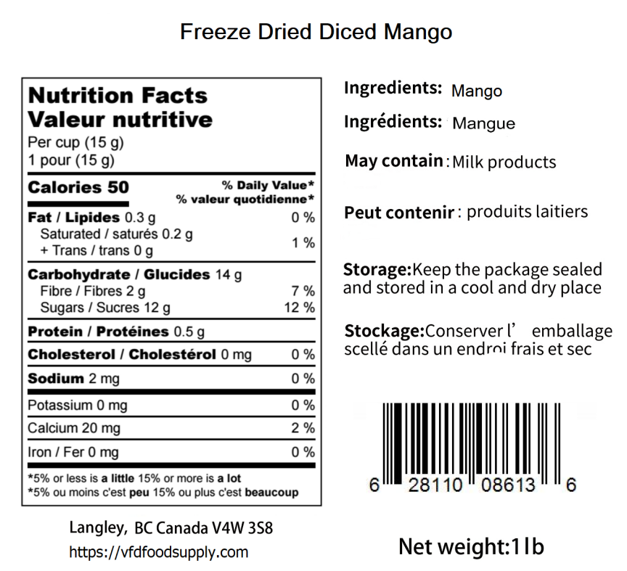

Brocolio

Broccoli

**Freeze Dried Broccoli**

**Freeze Dried Mango (Sliced)**

BB: LOT: