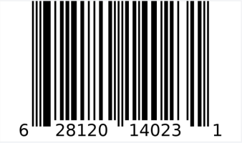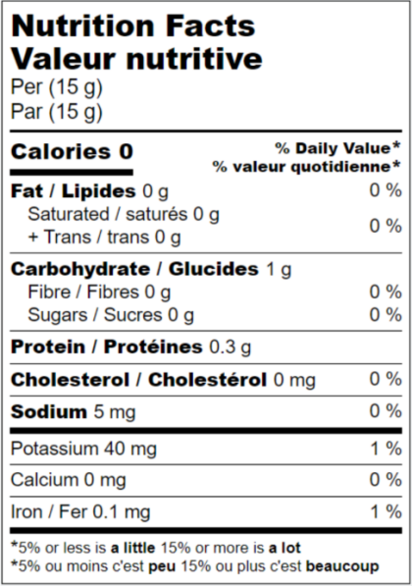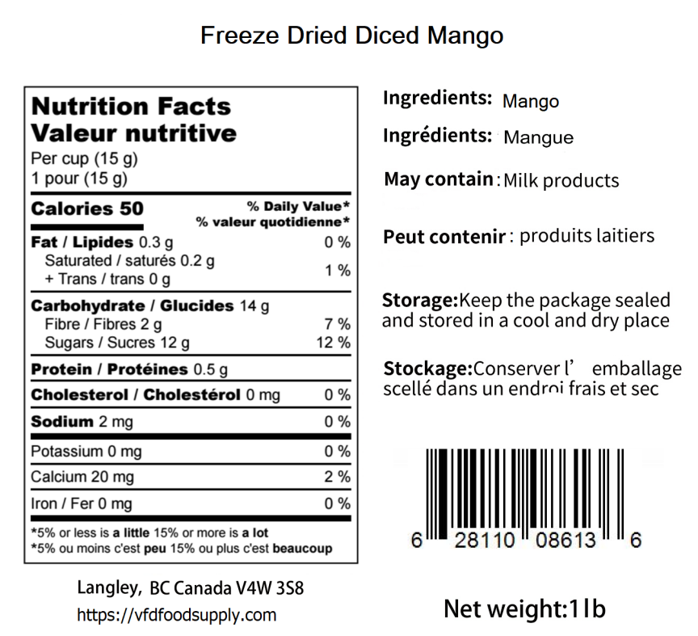

**0.5 lb**

Chou-fleur

Cauliflower

**Freeze Dried Cauliflower**

**Freeze Dried Mango (Sliced)**

BB: Jun 17, 2026 LOT:D223163CU