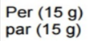
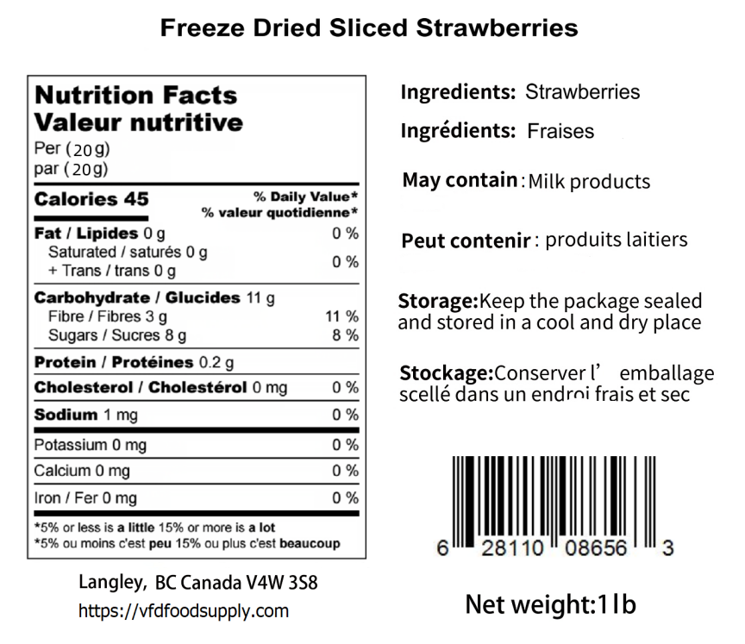

BB: Apr 05，2026 LOT: D223150STS

