C:\Users\Administrator\Documents\WeChat Files\kuz971\FileStorage\Temp\1702595778834.png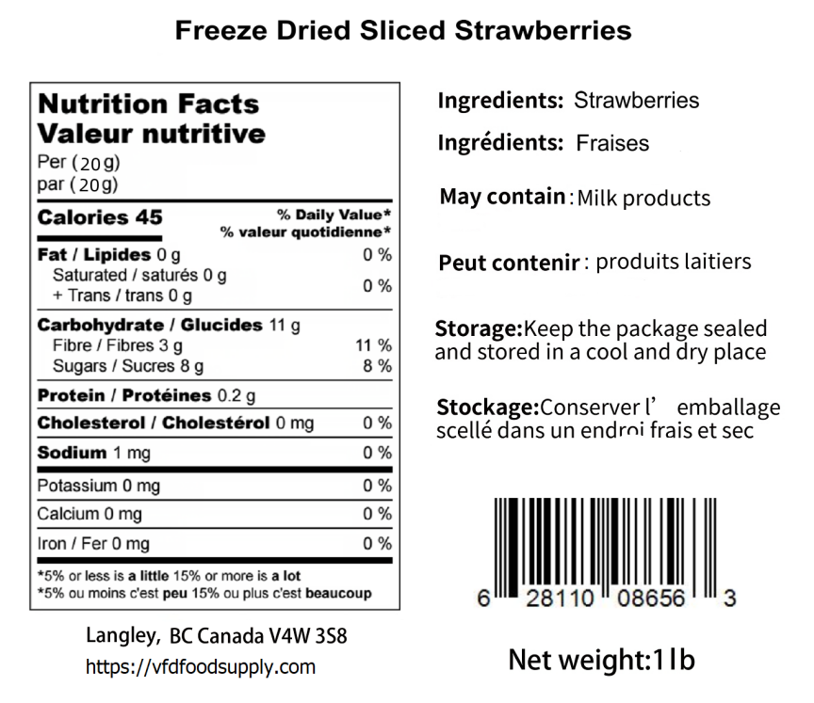

**Freeze Dried Strawberry Diced**

BB: Apr 05，2026 LOT: D223150STG