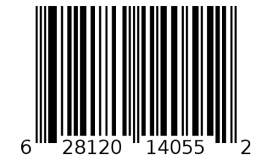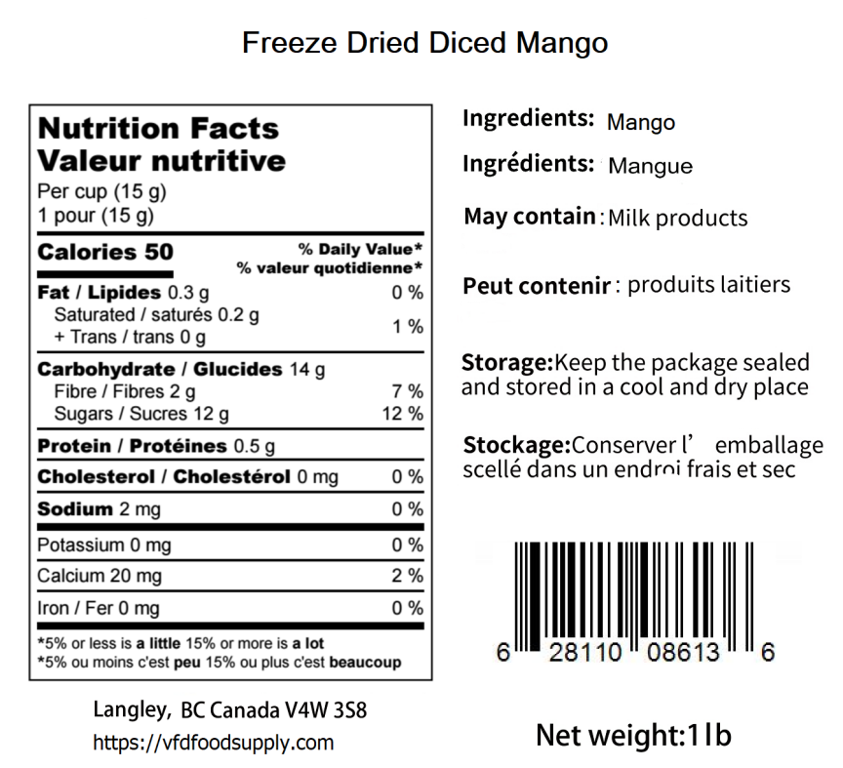

**Freeze Dried Mango (Powder)**

BB: Apr 01, 2026 LOT: D223143MAS