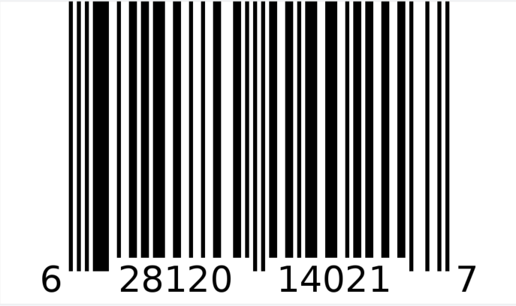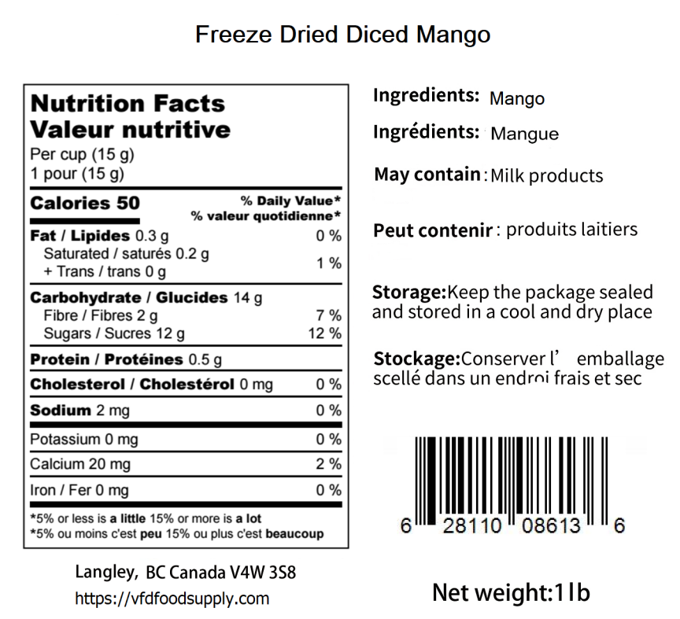

**Freeze Dried Mango (Sliced)**

BB: Apr 01, 2026 LOT: D223143MAS