Oatally Awesome Apple Cinnamon
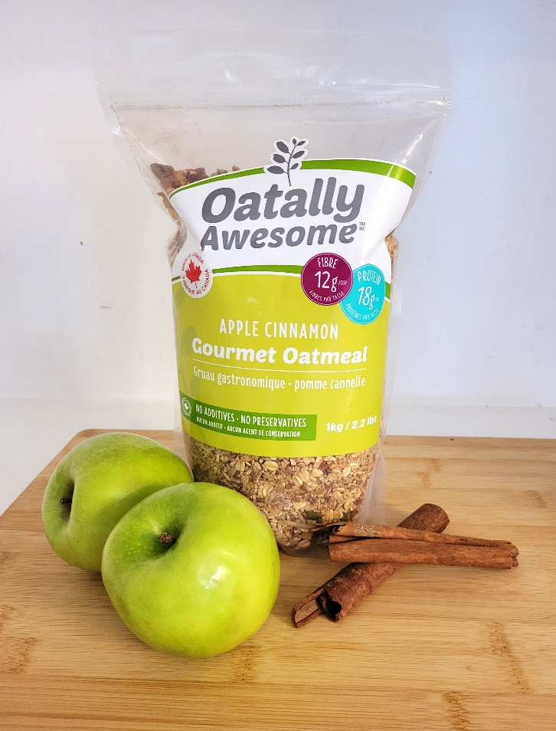
Ingredients:
- Steel Cut Oats
- Rolled Oats
- Dried Apple (unsweetened)
- Slivered Almonds
- Raisins
- Cinnamon
- Brown Flax Seed
- Hemp Hearts
- Sunflower Seeds
- Pumpkin Seeds
- Goji Berries
Available Sizes:
650 g or 1kg (1000g)

An Awesome Way to Begin Your Day!
Our Gourmet Oatmeal is a nutrient-rich mixture of whole grain oats (60% steel-cut oats and 40% rolled oats) seeds, goji berries, almonds, dried apple, and cinnamon.
Ways to use it:
- Cook as nutritional breakfast providing energy, protein, and fiber to start your day with.
- Make no-bake protein bars.
- Use in recipes where it calls for oats replace with Oatally Awesome for additional nutrition.
- Soak overnight for ready to go meal in the morning.

To purchase, please contact:
TYJ Products Inc.
Nanette Nielsen – 604-317-9277 or email info@oatallyawesome.com
Website: www.oatallyawesome.com

